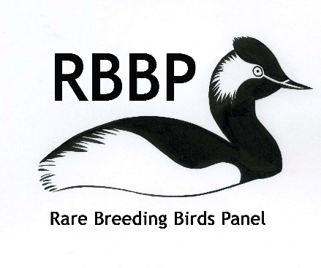
Rare Breeding Birds Panel Data Access Licence Agreement

Purpose of this Data Access Licence Agreement
Please describe what the data from the RBBP will be used for and the goal(s) of this work.

Description and purpose of the work:

Anticipated outcomes/outputs (e.g. conservation action, publications):

What public release of data or data products is anticipated as a consequence of this work (e.g. will the occurrence of specific species at specific sites be put into the public domain):

What feedback do you propose making to the RBBP on the outcomes of this work:

Timescale (and end date) of intended work:

Data Recipient
Name:

Email:

Organisation (if relevant):

What data are required?

Please specify the species, areas or sites, and time period data are required for. Data may be available for any year from 1973 until the year of the last RBBP report published; in some circumstances, more recent data may be available. Note that for some species, data were not collected by the Panel until later than 1973: consult the Secretary for details.

Species
Period data are required for (years X–Y)
County/bird recording area(s)
Site name(s) (or all within specified area)
Site grid reference(s) (if relevant)
For the species/site/year combination indicated above, please indicate what data you require (tick boxes):
☐ Counts (of possible, probable and confirmed breeding pairs)
☐ Additional data (may include breeding evidence, productivity data, specific dates, within-site location details, notes from observers)

This licence should be read in conjunction with the RBBP Data Access Policy (see https://rbbp.org.uk/wp-content/uploads/2020/07/Data-access-policy.docx) which describes the objectives of the Panel and how its data are used.

By signing and returning a copy of this licence, you are agreeing to abide by the terms of the RBBP Data Access Policy. Key points are listed below.

- Data supplied by RBBP are explicitly in relation to the purposes outlined above and for a defined period.

- The Data Recipient named below must be discreet about the disclosure of data and information in any more detail than is required for the particular purposes for which they are required. Any intended disclosure of data should be indicated on this application.

- Any public release of site-specific data must be detailed above and with the express permission of the RBBP.

- Security of the data must be maintained. This means that site-location data is kept secure in a safe place accessible only to the named Recipient. Electronic versions of site-location data must be password protected and access given to other users only with explicit permission of the Panel. It is imperative that data are not shared with any other party without prior agreement with RBBP.

- It is expected that the Data Recipient will be supportive of the Panel’s objectives in their dealings with volunteers and the planning of professional or other surveys.

- Site-location data must be used wisely to promote and secure the conservation of critical sites and species, and for no other purposes without explicit Panel approval.

- Where available, other relevant data in the possession of the Recipient should be supplied on a regular basis to RBBP to supplement the Panel’s records.

- Recipients of data will be asked to seek formal permission to continue to use the data after the agreed period. In view of the undesirability of the maintenance of parallel datasets for the same species, reciprocation of data exchange with some users is important.

- Those being supplied with significant amounts of data on a regular basis for agreed conservation uses will be required to make an annual return to the Panel at the end of each calendar year detailing the uses of these data.

- All reports and records supplied by the Panel, in whatever form, will carry the name of the Recipient and a summary of these conditions with which the Recipient has agreed to abide.

- Full acknowledgement to the Panel will be made on all relevant reports and publications using RBBP data or derived information. An example acknowledgement is as follows:
“We are grateful to the Rare Breeding Birds Panel for the provision of data. The Panel depends on the efforts of a large number of volunteer and professional birdwatchers throughout the UK, particularly the network of County and Regional Bird Recorders, and is supported by RSPB, JNCC and BTO.”

- The Panel should be notified of all reports and publications made using Panel data and should be provided with an electronic copy for its archive. It is desirable where possible, that such publications are made available via the Panel’s website to indicate to data providers the range of uses of Panel data.

- In the event of the potential need to publish data as ‘supplementary information’ supporting an academic publication, early communication with the Panel is required. In most cases open access to data in this way would not be feasible and potential authors should be aware of this.

- The Panel may terminate any arrangements with any individual or organisation that fails to uphold these data supply terms. It reserves the right to require the return of any data supplied in the event of the conditions not being met.

- The Panel Secretary will hold information about recipients of data in compliance with General Data Protection Regulations with regard to personal information.

The following additional stipulations have been made by the RBBP concerning this specific release of data:

Signed (Data recipient)
Date

Signed (RBBP Secretary)
Date

